Sprint 3

|  |  |
| --- | --- |
| Team ID | PNT2022TMID43478 |
| Project Name | Personal Assistance for Seniors Who Are SelfReliant |

Mobile Application

1. Splash Screen :

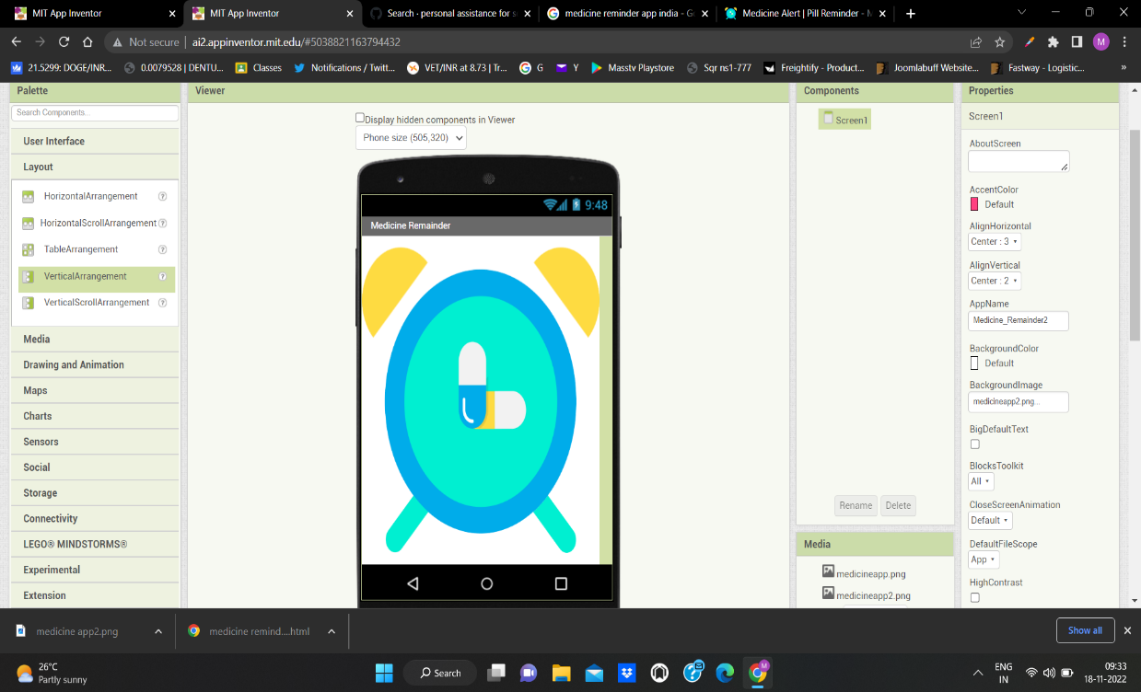

1. Blocks for Splash Screen :

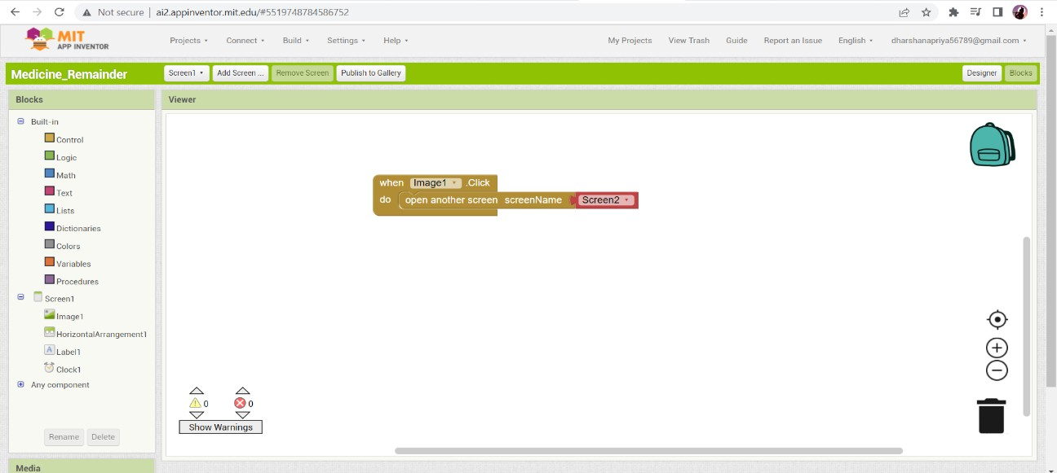

1. Get medicine data from user :

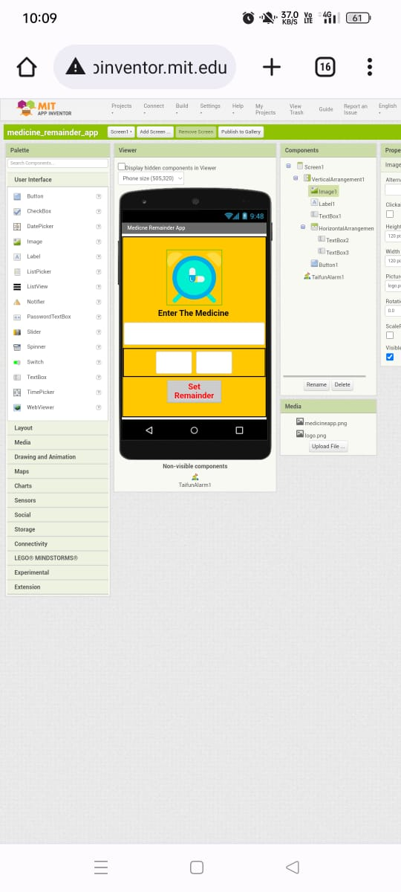

1. Blocks for user input:

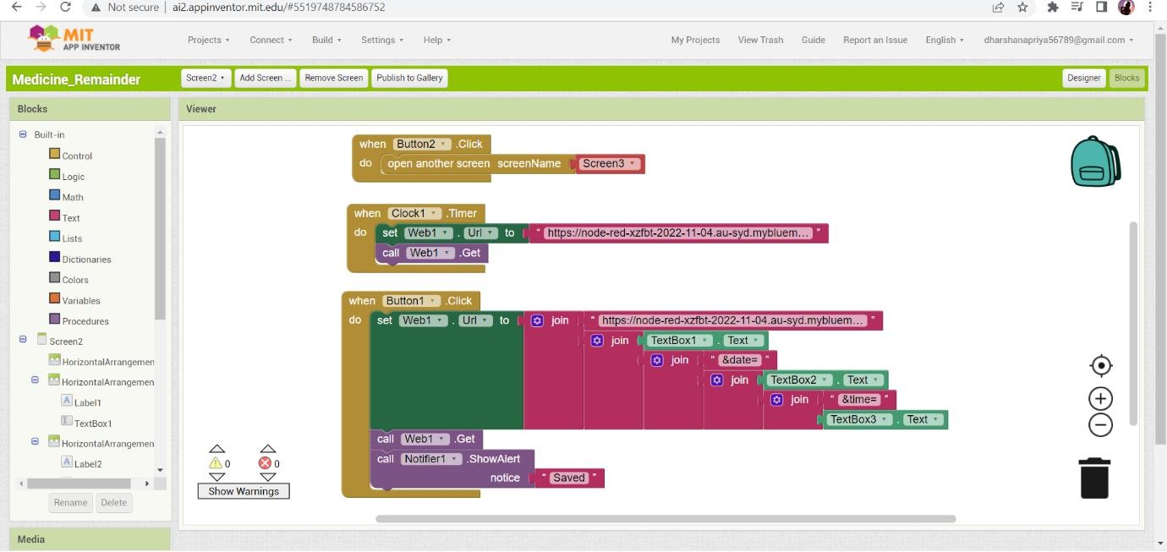

1. Display Remainder with audio in mobile :

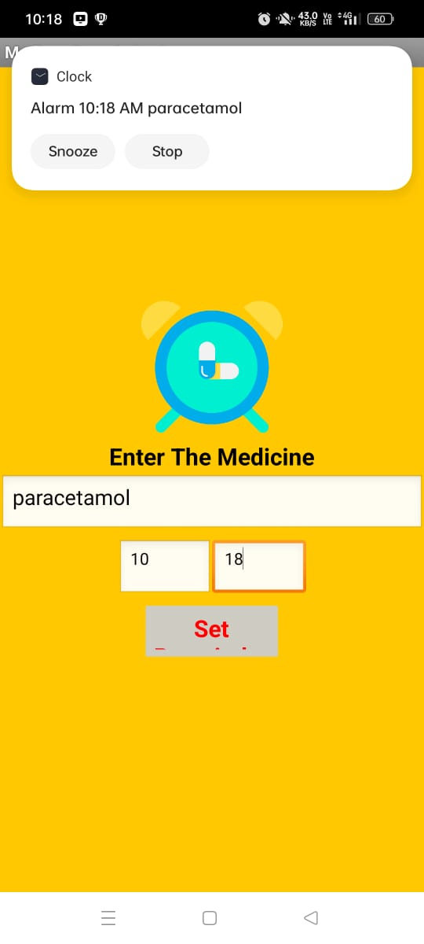

1. Blocks for Remainder :

